**PROJECT REPORT**

**GRAPHICS DESIGN USING CANVA**

1. **INTRODUCTION**
   1. Overview

The speech and debate competition award certificate is an official document provided to the participant by higher management as a token of appreciation.

* 1. Purpose

These awards motivate non-participants to take part in such activities and get appreciated by other people for their talent and skills.

1. **PROBLEM DEFINTION**
   1. Empathy Map

C:\Users\Admin\Documents\project\empathy map.pdf

* 1. Brainstorming Map

C:\Users\Admin\Documents\project\brainstorming map.pdf

1. **RESULT**

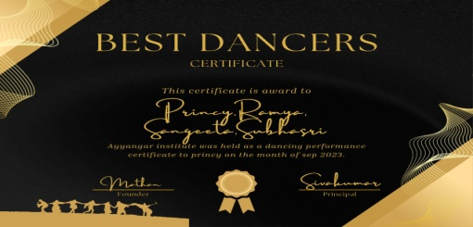

1. **ADVANTAGES & DISADVANTAGES**

i)Recognition and credit i) Arrogance

ii)Structured learning ii)Biases

1. **APPLICATIONS**

We use the *CANVA* application to design a debating certificate.

1. **CONCLUSION**

Crafting practical certificate text is crucial in conveying the intended message accurately.

*************